A supplement with BERTopic
A topic-extraction method named BERTopic (Grootendorst, 2022), as shown in Supp.1, uses the Transformer architecture and BERT model (Devlin et al., 2018) to extract insights from text documents. Texts are embedded with Sentence-BERT (Reimers & Gurevych, 2019), reduced in dimension with UMAP (McInnes et al., 2018), and clustered with HDBSCAN (McInnes et al., 2017). CountVectorizer and c-TF-IDF then identify key keywords (Wi) to create topic labels (Ki). BERT’s encoder with multi-head self-attention provides contextualized word representations, while residual connections and layer normalization help ensure stable training, making BERTopic effective at capturing semantically rich topics.
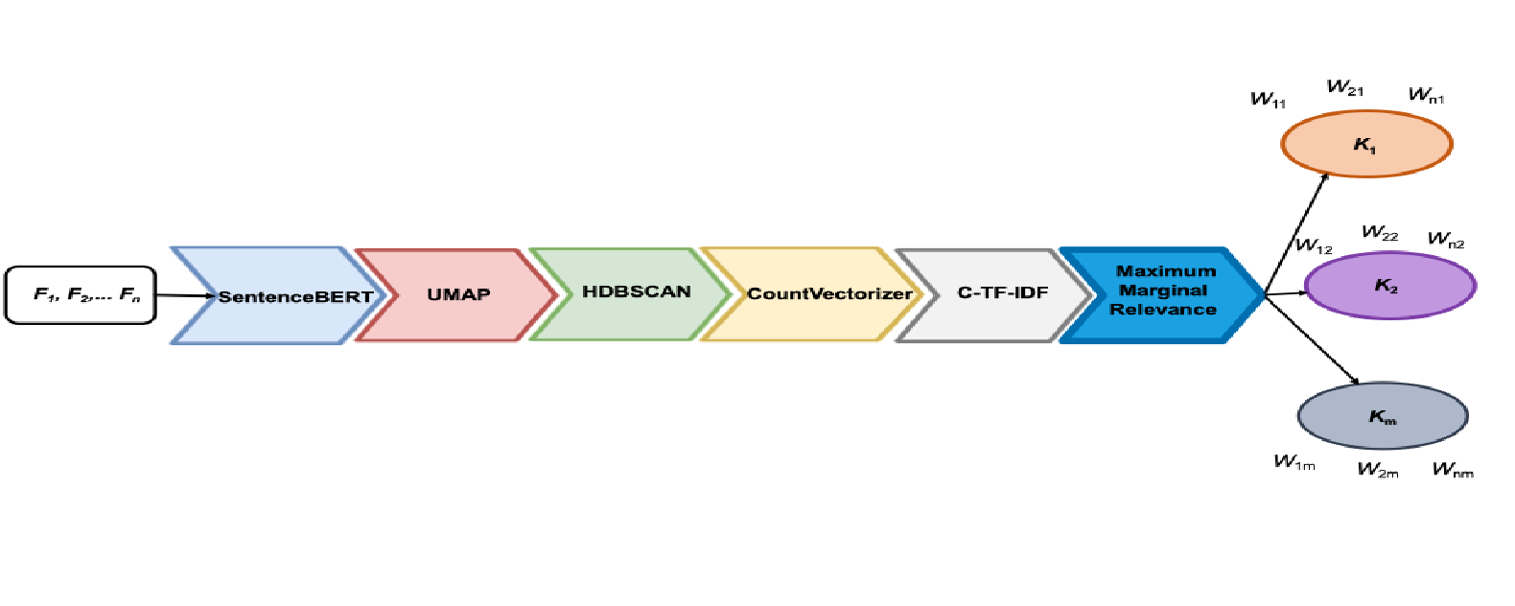
Supp.1. BERTopic process (Grootendorst, 2022).
Document vectorization: Sentence-BERT, an enhanced variant of BERT, improves efficiency in measuring semantic similarity between sentences or documents and generates 768-dimensional embeddings (Supp. 2). While these embeddings represent text meaningfully, intermediate processing is required to transform them into usable topic representations.
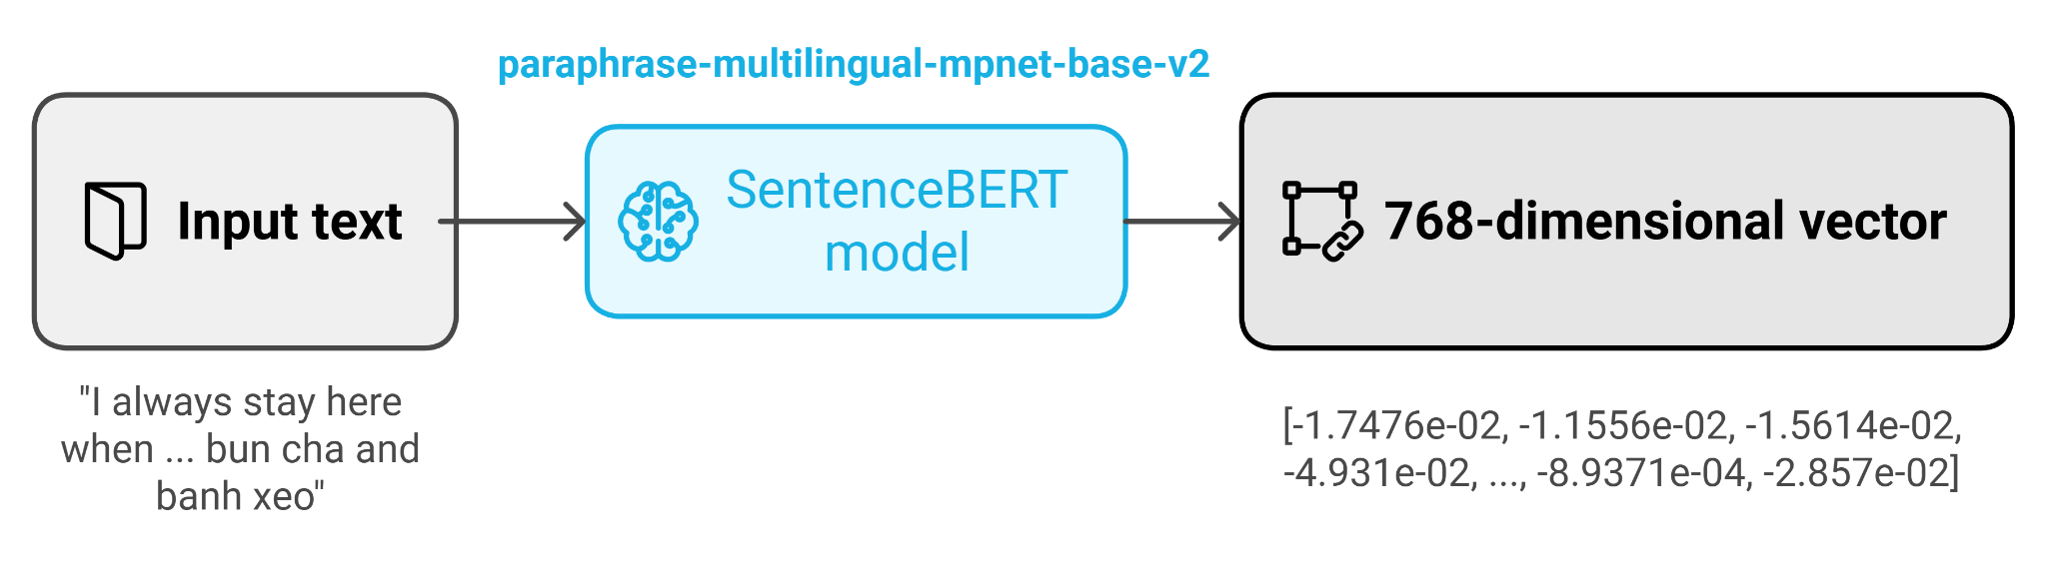
Supp.2. SentenceBERT vector embeddings of input text.
Dimensionality reduction: The high dimensionality of BERT embeddings necessitates dimensionality reduction for clustering. UMAP transforms high-dimensional data into a lower-dimensional space while preserving relationships, and HDBSCAN in BERTopic improves topic modeling and visualization in BERTopic.
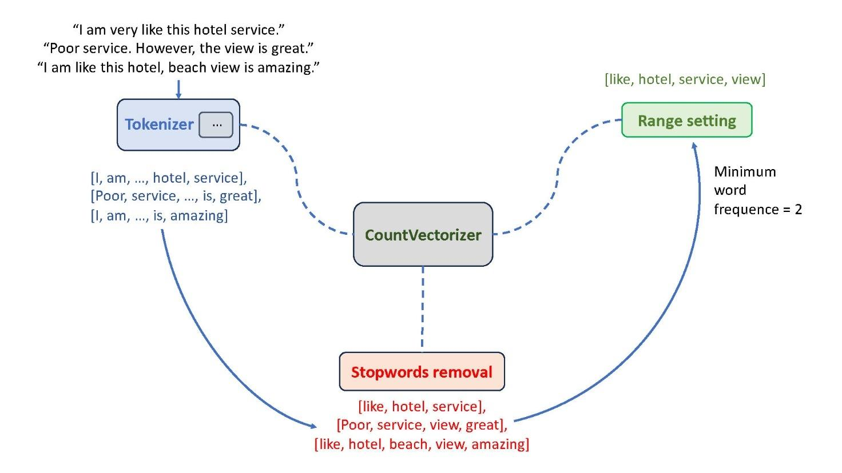
Supp.3. Vector visualization of count vectorizer technique.
Embedding clustering: BERTopic employs HDBSCAN to cluster UMAP-reduced BERT embeddings and identify latent themes. Unlike K-means, HDBSCAN handles noise, automatically determines cluster numbers, detects outliers, and constructs a hierarchical density tree to support topic labeling and visualization.
Count vectorizers: After clustering documents by content similarity, defining a topic representation for each cluster is essential. BERTopic applies statistical techniques and CountVectorizer to extract key terms and generate word frequency counts, thereby enhancing topic representation and improving topic quality (see Supp.3).
Key term identification: Topic representations rely on distinct word distributions within clusters, with class-based TF-IDF (c-TF-IDF) applied to assess term significance. By replacing IDF with Inverse Class Frequency (ICF), keyword informativeness is measured across clusters, enhancing topic interpretability while accounting for stop words and rare terms (see Supp.4).
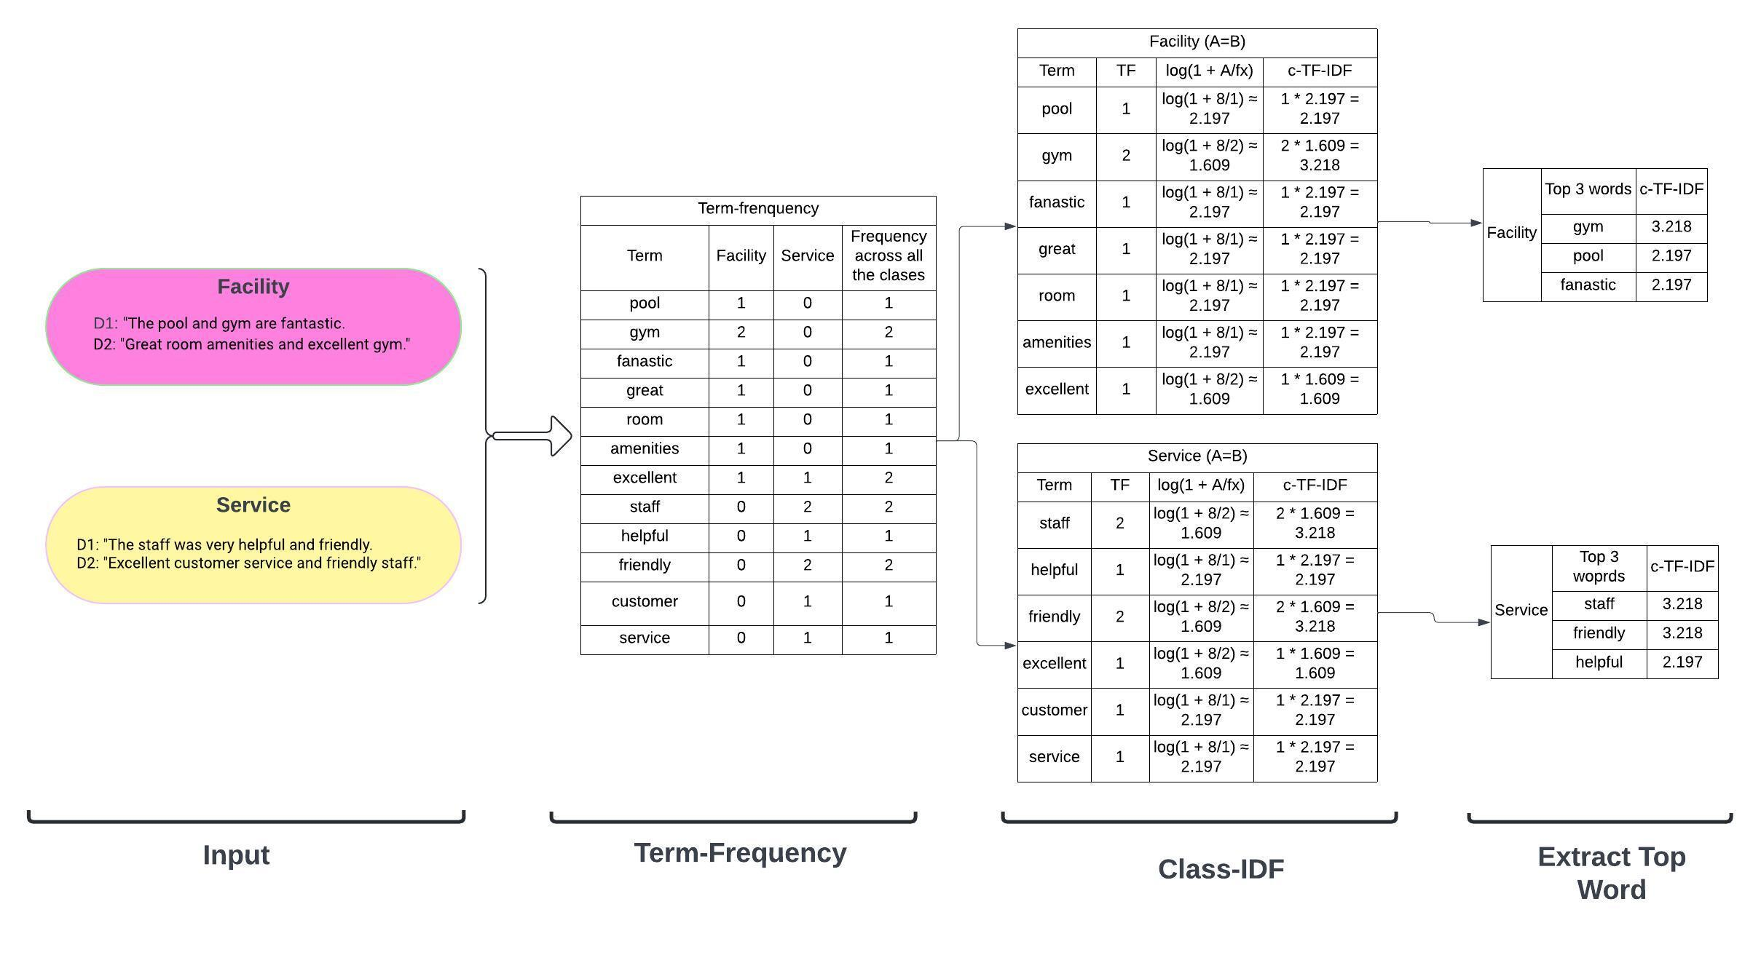

Supp.4. Extracting topwords using class-based TF-IDF.

Rereferences
- Grootendorst, M. (2022). BERTopic: Neural topic modeling with a class-based TF-IDF procedure. arXiv preprint arXiv:2203.05794.
- Devlin, J., Chang, M. W., Lee, K., & Toutanova, K. (2018). Pre-training of deep bidirectional transformers for language understanding. arXiv. arXiv preprint arXiv:1810.04805.
- Reimers, N., & Gurevych, I. (2019). Sentence-BERT: Sentence Embeddings using Siamese BERT-Networks. arXiv preprint arXiv:1908.10084.
- McInnes, L., Healy, J., & Astels, S. (2017). hdbscan: Hierarchical density based clustering. Journal of Open Source Software 2(11), 205.
- McInnes, L., Healy, J., & Melville, J. (2018). Umap: Uniform manifold approximation and projection for dimension reduction. arXiv preprint arXiv:1802.03426.

